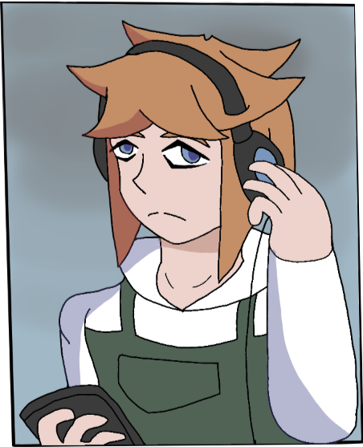

Name: Kelvin Hugh

Age: 24

Birthday: 2078

Gender: Male

Height: 5,7 (170cm)

Weight: 64kg

Nationality: Australian

Occupation: Factory Worker

Manga Debut: Chapter 1 - Degrees Celsius

Kelvin Hugh is the main protagonist of Degrees Celsius. He begins the story as a simple factory worker just trying to get by in life but his frequent criminal activity and bad encounters lead him down a dangerous path.

**Appearance**

Kelvin is a young man with average height and a slender athletic body.

His hair is short,orange and and spiky consisting of three curved spikes that flow out to the sides, three smaller spikes at the back, with straight hair that reaches down to his shoulders and gets shorter around the back of his head. He also has sharp blue eyes.

His typical outfit consists of a white shirt with short sleeves, green overalls and a pair of brown work boots. He is often also seen wearing a pair of black headphones.

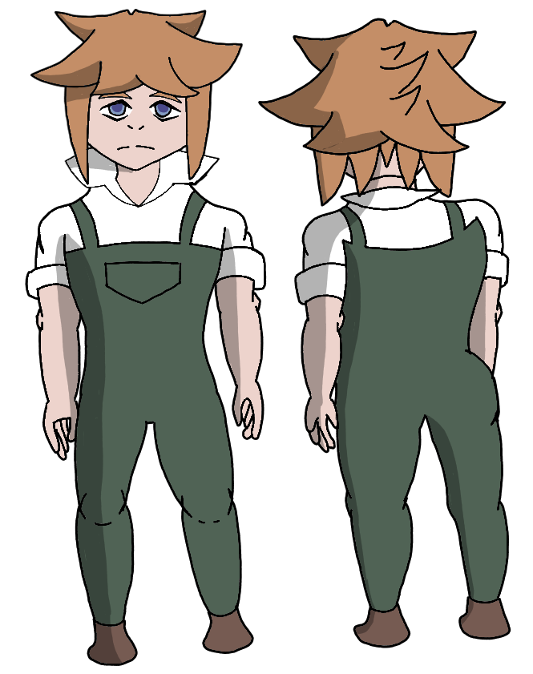

**Personality**

Kelvin is a quiet, timid and introverted man who tries to maintain a calm and professional demeanor. He tends to do as he's told by those of higher status than him and doesn't like to get in trouble. When a woman with a low score asks for his help to get on a train, Kelvin refuses to do so in fear that helping somebody with a low score will get him into trouble. Despite this however Kelvin often does illegal acts in secrecy when he thinks nobody is aware of what he's doing, such as when Shibana catches him listening to Mozart, an illegal song that can reduce the score of anyone who listens to it. Or when he uses a signal disruptor to hack into the prime minister's internet to listen to more illegal music. Even when Kelvin is caught doing things he shouldn't, Kelvin is willing to resort to bribery inorder to get away with his crimes.

Kelvin also seems to be dependent on drugs, mainly Neurotransmitters which he described as helping him focus. He blamed being unable to take his medication as a reason for getting distracted while at work.

**Backstory**

As a child Kelvin wasn't very popular at school, he was often looked down on and avoided by others due to being live born,with his synthetically created peers viewing Kelvin as a genetically inferior abomination. After witnessing a group of bullies harass another live born kid named Colton. Kelvin decides to stand up for them and ends up in a fight against an unknown bully where he proceeds to win the fight effortlessly however while Kelvin is on-top of them and in the middle of beating them up he's caught by the teacher who tells him to stop what he's doing.

The unknown bully immediately runs towards the teacher and lies to the teacher telling them that Kelvin is psychopathic and went crazy due to being live born. Kelvin attempts to explain the truth but the teacher cuts him off and shuns him, telling him that she would get the authorities involved and that Kelvin's parents were a bad influence on him.

Later that evening Kelvin walks home with Colton and the two have a conversation where it's revealed Kelvin's father was detained and taken to Re-Education 4 years ago. Kelvin explains he was detained for saying something he shouldn't and it's heavily implied his father isn't coming back possibly due to being killed. Upon arriving home Kelvin sees his mother being arrested and is shocked. It's explained his mother is being sent to Re-Education due to the fight at school. Kelvin begs the police not to take her mother away only to be assaulted by one of the cops.

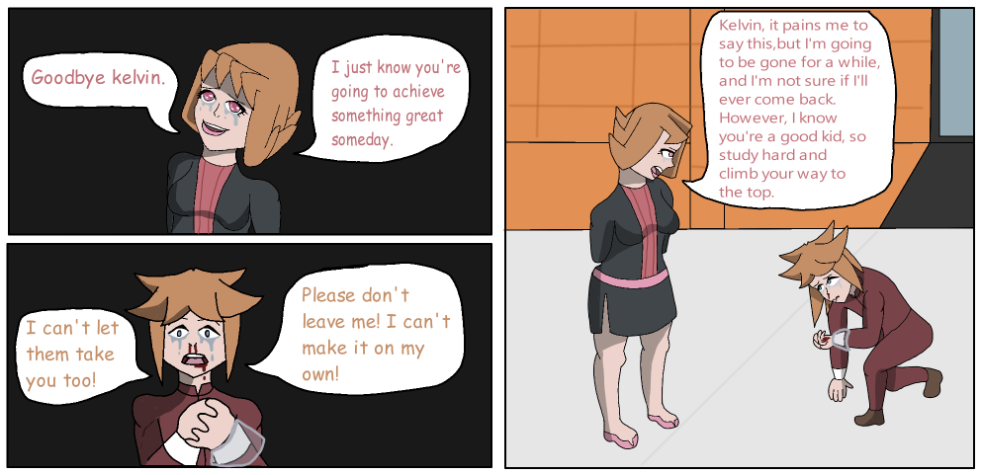

After seeing him get assaulted Kelvin's mother asks to speak to Kelvin one last time. She promises him that she will return and asks him to work hard and study in school because she believes he has potential to be great. After a short exchange she's put in a police van and is taken away.

**Skills**

Technology Expert: Kelvin is an expert with computers and robotics and enjoys tinkering with them in his spare time. It was mentioned by his boss that in the past Kelvin was able to fix one of the company's computers before anyone from the repairs department had even showed up, earning Kelvin a promotion at his job. Upon taking apart Shibana's signal disruptor Kelvin was immediately able to recognise what it was and how it functioned. He was also able to take the device apart and install some of the pieces into his phone which allowed him to hack into the Prime Minister's private internet with ease.

Martial Arts: Kelvin is skilled with martial arts and hand to hand combat. He's demonstrated the ability to defend himself and hold his own in a fight even at a young age. How he developed this skill is unknown.

**Relationships**

Mother: Kelvin's mother acts as a support system for Kelvin when he is young. When she is taken to Re-Education Kelvin becomes extremely upset and begs the police not to take her away. Kelvin described her as caring and passionate.

Father: Kelvin didn't know how father for very long due to them being taken away to Re-Education when he was very young but he doesn't consider his father a dead beat because of this.

Colton: Coton is a live young student at Kelvin's school who befriended Kelvin after they stood up for him against a group of bullies. It is unknown what their relationship is like in the current day.

Liam: Liam is Kelvin's boss and is the manager at the factory he works at. Unlike his supervisor Alonza, Liam appears to be more respectful and understanding of Kelvin, willing to give Kelvin second chances and even an opportunity to be promoted.

Alonza: Alonza is Kelvin's supervisor. She is rude and cruel towards him and is quick to scorn him for getting distracted at work. During the meeting at Liam’s office she claims that his score should be reduced or that he should be sent to Re-Education.

Shibana: Shibana is a stranger who takes interest in Kelvin after witnessing Kelvin display unusual behavior. The two share a mutual love of classical music and Shibana appears to try and give Kelvin advice and show Kelvin a new perspective on the world however Kelvin appears to be mostly afraid of and confused by him.

**Chapters**

Chapter 1: - Degrees Celsius

Chapter 2: - Mayhem Devil

**Quotes**

“I can't. If I help you'll just drag me into your problems” - Chapter 1

“It's a shame that ended violently but what was he thinking? Struggling against authority is a pointless pursuit that will only lead to being crushed.” - Chapter 1

“That kid didn't choose how he was born. He hasn't done anything wrong so quit picking on him.” - Chapter 2